New Jersey Citi Bike Analytics Aug to Oct 2019

Source: <https://www.citibikenyc.com/system-data>

Data: <https://s3.amazonaws.com/tripdata/index.html>

Task: In this project is to aggregate the data found in the Citi Bike Trip History Logs and find two unexpected phenomena.

Design 2-5 visualizations for each discovered phenomenon (4-10 total). You may work with a timespan of your choosing. Optionally, you may merge multiple datasets from different periods.

Create a Tableau story that brings together the visualizations, requested maps, and dashboards.

Timespan data: August to Oct 2019 NJ data

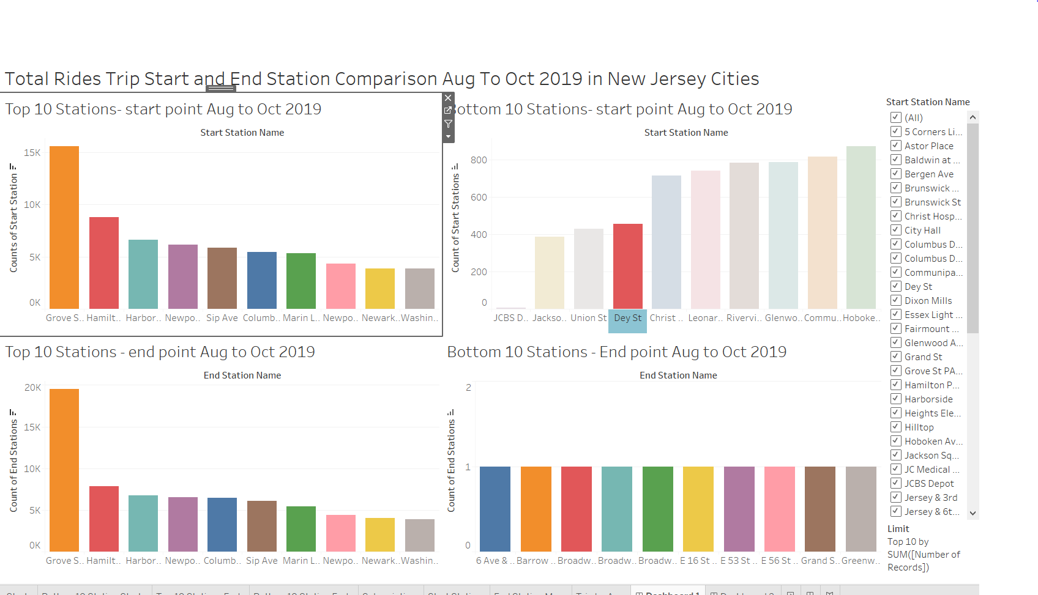

Above is the Top 10 and Bottom Start and End Station Comparison Aug to Oct 2019 in NJ

Showing Grove St Path has the most Starting and End Station compare to other cities

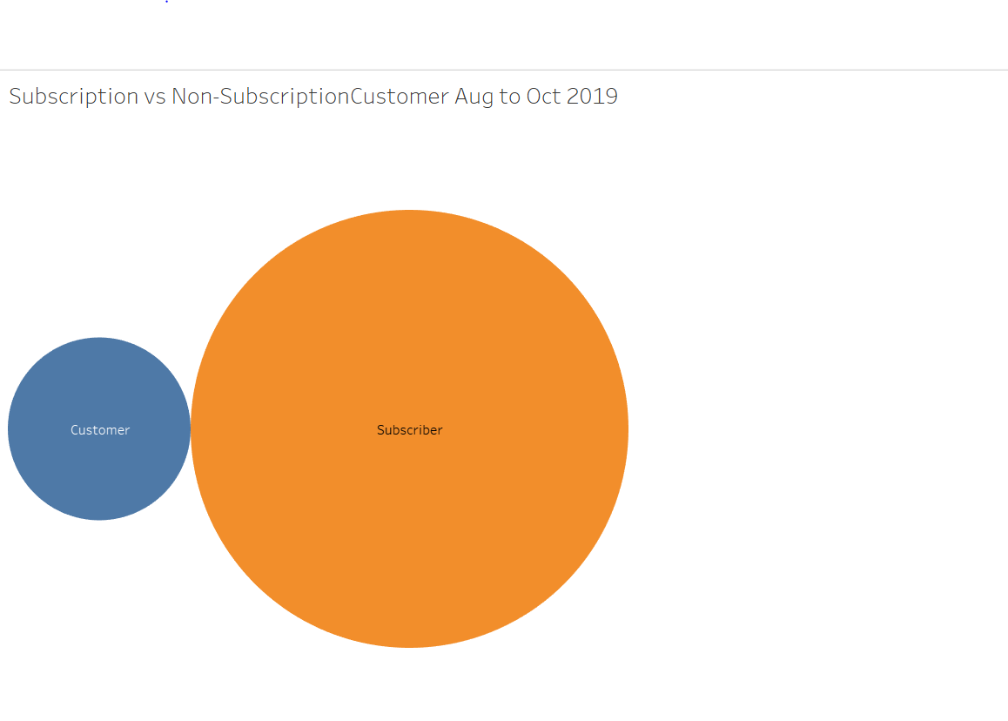

Above is a comparison Subscriber vs Non-Subscriber

Data shows Subscriber use the Citi bike more often

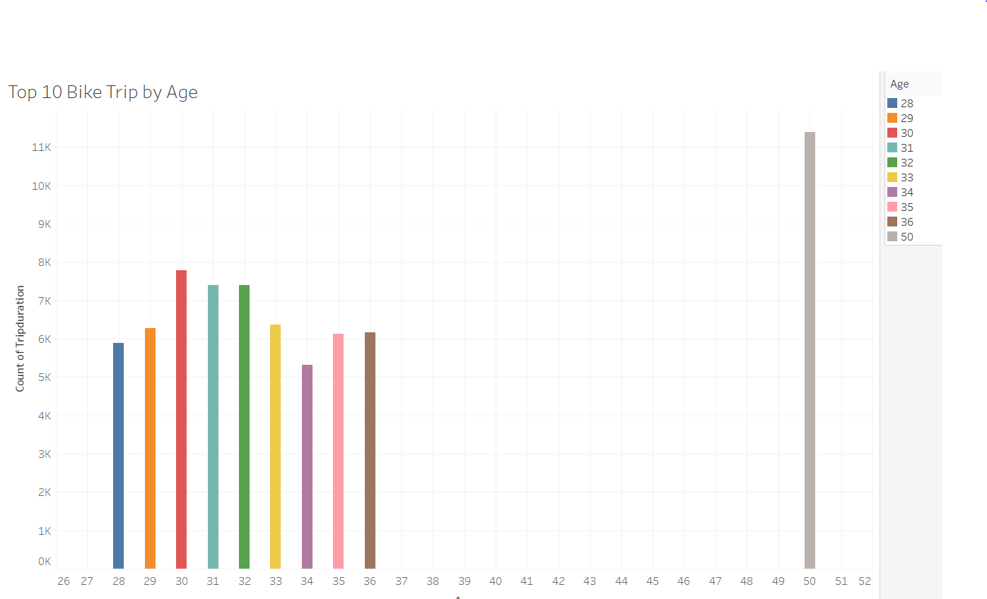

Above is Top 10 Age using the bike trip in the city

It appears customer at 50 year of age using the most trip

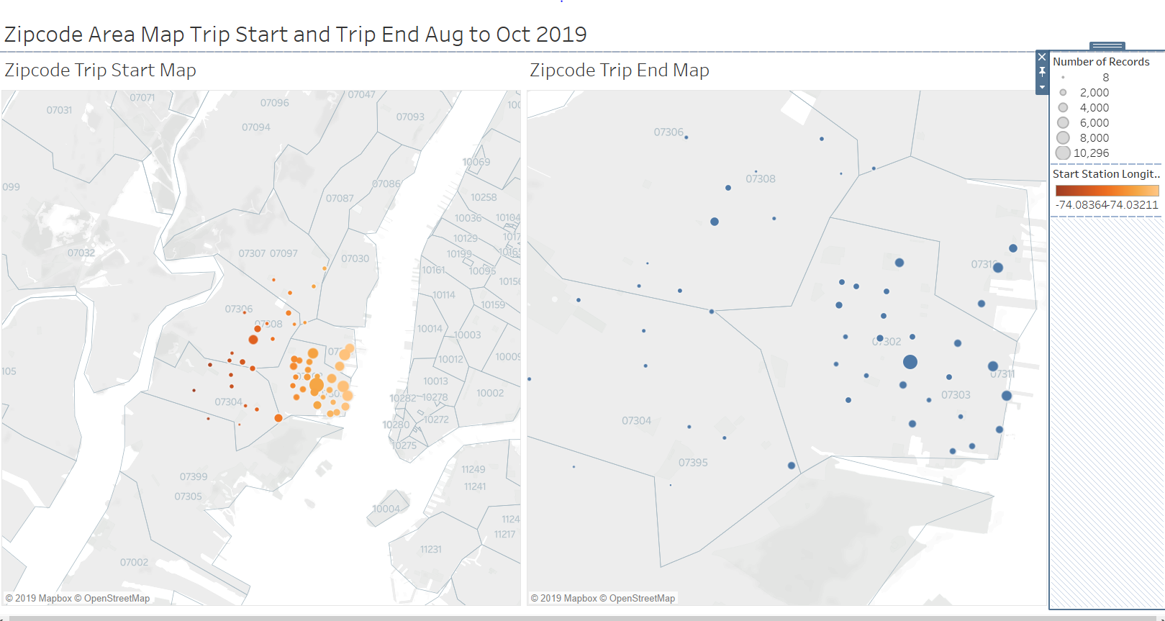

Above is map showing Zip code trip start and end trip